

Travlr Getaways Full Stack Web Application

CS 465 Project Software Design Document
Version 1.0

Table of Contents

CS 465 Project Software Design Document 1
Table of Contents 2
Document Revision History 2
Instructions 2
Executive Summary 3
Design Constraints 3
System Architecture View 3
Component Diagram 3
Sequence Diagram 4
Class Diagram 4
API Endpoints 4
The User Interface 4

Document Revision History

Version | Date | Author | Comments
1.0 | 2/7/26 | Sylvia Davis | Updated by Sylvia Davis
1.0 | 1/22/26 | Sylvia Davis | Updated by Sylvia Davis
1.0 | 2/19/2026 | Sylvia Davis | Updated by Sylvia Davis

Executive Summary

A full stack architecture was used in the creation of the Travlr Getaways online application, which supports both an administrative single-page application and a customer-facing website. The application is constructed using the MEAN stack, which consists of MongoDB, Express.js, Angular, and Node.js, and adheres to the Model-View-Controller architectural pattern. In order to guarantee scalability, maintainability, and a distinct division of responsibilities between the client interface, business logic, and data storage layers, this design was chosen.
Users can browse travel locations, examine trip details, and engage with dynamically rendered material in the application's customer-facing section. On the server side, Handlebars templates dynamically render material collected from structured data sources, while Express.js and Node.js handle routing, application logic, and database communication.
This strategy makes it possible for the application to effectively provide users with current and customized information.
The system consists of an Angular-built administrator single-page application in addition to the customer-facing website. Trip data saved in the MongoDB database may be created, updated, and managed by administrators thanks to the SPA's powerful client-side capability. Real-time changes are made possible by the SPA's communication with the server via RESTful API endpoints, which eliminate the need for complete page loads. These elements work together to provide a unified full stack solution that satisfies the client's needs for long-term maintainability, scalability, and usability.

Design Constraints

The architecture and implementation of the Travlr Getaways web application are impacted by a number of design limitations. The need to employ the MEAN stack, which specifies the technologies for the database, server-side logic, and client-side application, is one of the main limitations. Although this offers uniformity throughout the stack, careful component integration is necessary to guarantee compatibility and effective data flow.
The requirement to operate a separate administrative SPA and a conventional customer-facing website inside the same system is another significant limitation. To avoid tight coupling and guarantee that administration functionality does not impede the public-facing experience, presentation layers and API services must be clearly separated. The system must also be built to accommodate future expansion, including more features and traffic, which puts restrictions on the organization and accessibility of data.
The application design is also limited by security and performance issues. API endpoints must be designed to prevent unauthorized access to sensitive data, and administrative activities must be limited to authorized users. These limitations affect choices for server-side processing, data validation, and authentication methods. When taken as a whole, these design limitations direct the development process while guaranteeing the application's stability, security, and scalability.

System Architecture View

Component Diagram

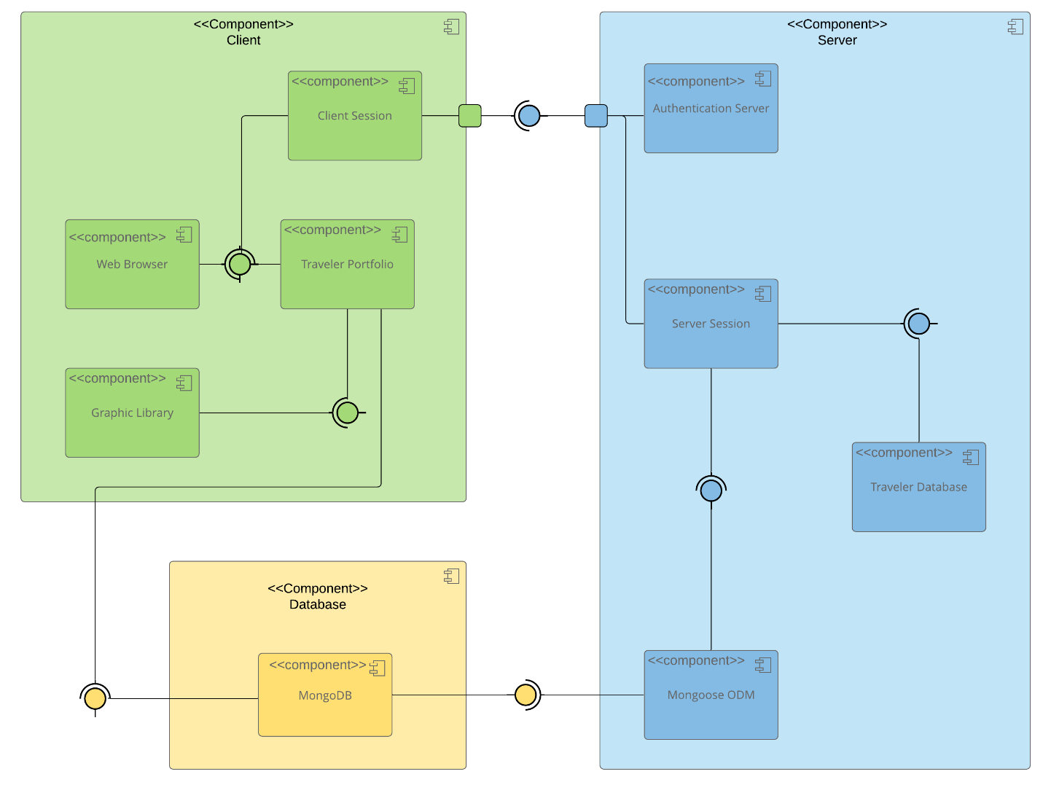

A text version of the component diagram is available: CS 465 Full Stack Component Diagram Text Version.

As seen in the component diagram, the Travlr Getaways web application has a multi-tier architecture that divides duties among many components. Users engage with either the administrative single-page application or the customer-facing web interface at the presentation layer. The administrative SPA uses Angular to improve interactivity, while the customer-facing interface uses Handlebars templates to deliver dynamic content.
The Express.js server, which runs on Node.js, makes up the application layer. This layer controls communication between the data layer and the display layer as well as routing and application logic. Incoming requests are handled by controllers, which also process business logic and call services or data access components when necessary. This layer exposes RESTful API endpoints that allow the SPA to create, read, edit, and delete application data.
MongoDB, which stores travel information and other application data in an adaptable, document-oriented format, is used to create the data layer. All data access is centralized and restricted because this database only interacts with the server-side application layer. These elements cooperate to create a scalable, maintainable system with distinct roles and responsibilities for each layer.

Sequence Diagram

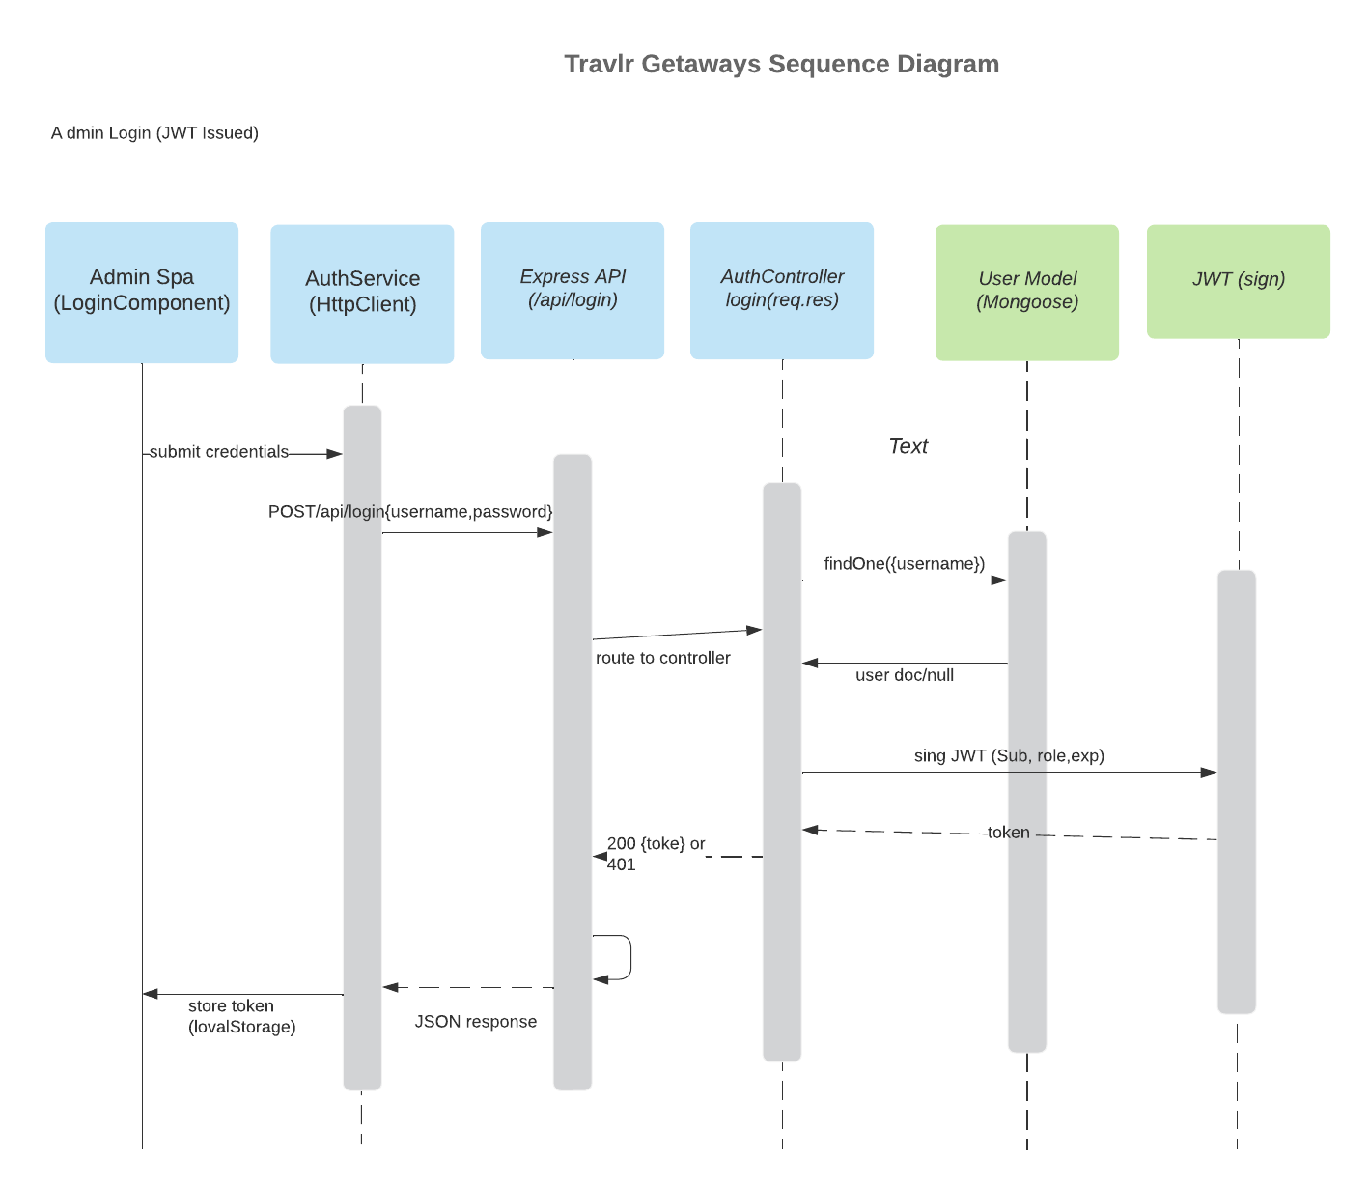

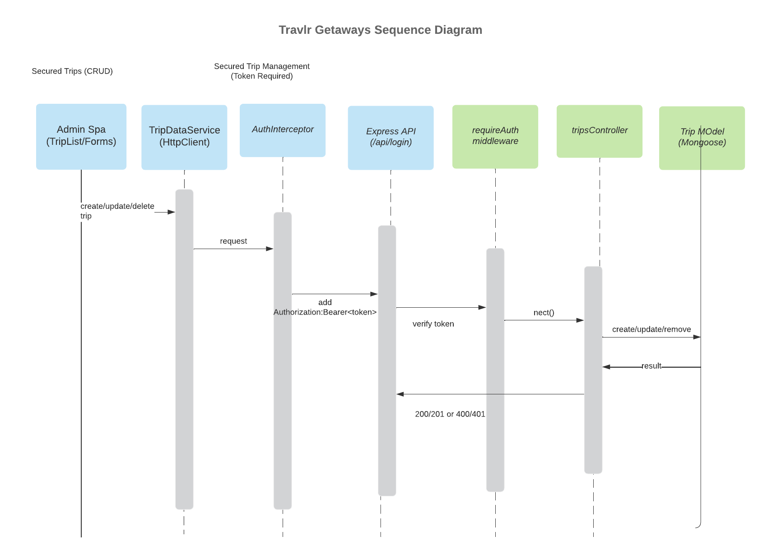

The sequence diagram illustrates the end-to-end flow for secure admin operations in the Travlr Getaways SPA. An administrator submits credentials through the Angular LoginComponent, which calls AuthService (HttpClient) to POST /api/login. The Express API routes forward the request to AuthController.login, which queries the User model (Mongoose) and MongoDB to validate the password. On success, the server returns a signed JWT token. The SPA stores the token in localStorage. For administrative trip management (create, update, delete), the SPA sends requests to /api/trips with an Authorization header in the form 'Bearer <token>'. The requireAuth middleware verifies the JWT and then allows the TripsController to perform Trip CRUD operations through the Trip model and MongoDB, returning JSON results back to the SPA. Unauthorized requests (missing/invalid tokens) are rejected with 401 responses.
These RESTful endpoints allow the front end to retrieve trip information and allow authorized users to manage trip data. GET endpoints support read-only customer experiences, while POST/PUT/DELETE enable administrative trip management. Authentication endpoints support secured access to protected operations.

Class Diagram
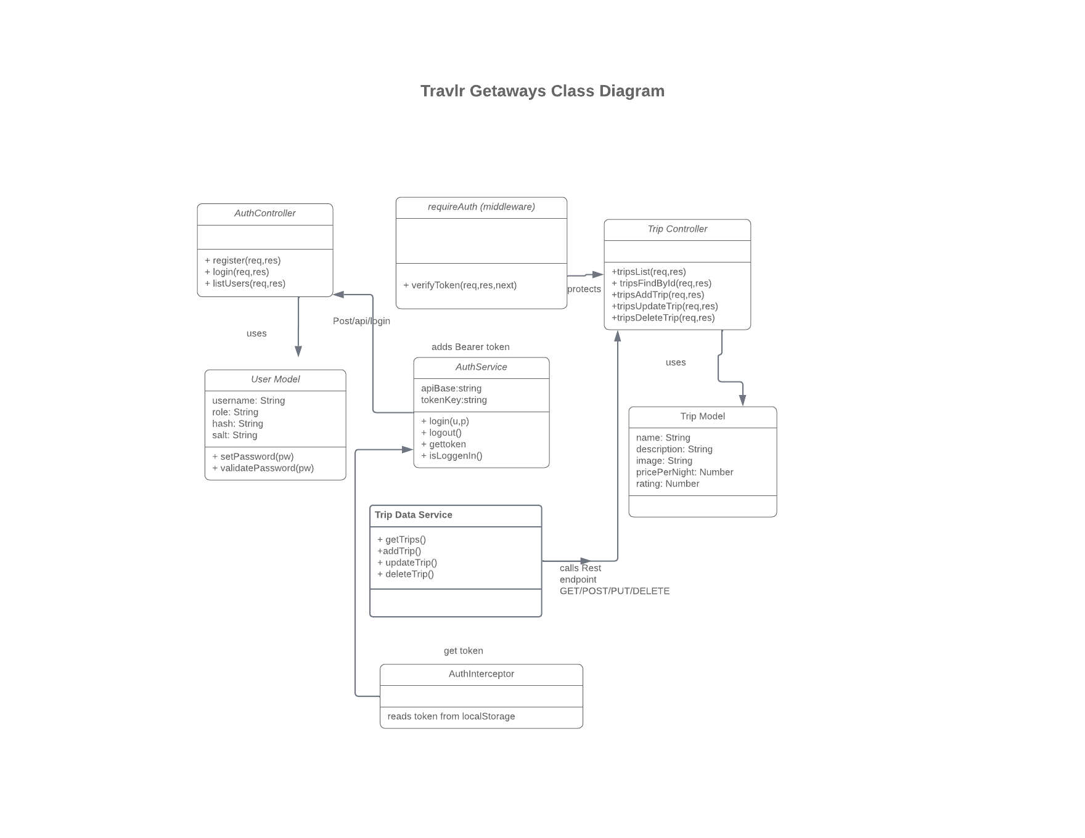

The class diagram reflects the actual JavaScript/TypeScript classes used in the Travlr Getaways MEAN-stack implementation. On the server side, Trip and User are Mongoose models that define the persistent schema stored in MongoDB. AuthController exposes the /api/register, /api/login, and /api/users endpoints and uses the User model for account creation and password validation. TripsController exposes the /api/trips endpoints and uses the Trip model for retrieving and maintaining trip packages. The requireAuth middleware secures administrative endpoints by validating JWT Bearer tokens and attaching the decoded user payload to req.user. On the SPA side, AuthService handles login/logout and token storage, AuthInterceptor attaches the token to outgoing API requests, and TripDataService performs CRUD operations against the secured /api/trips endpoints.

API Endpoints

Exposing RESTful endpoints allows the Travlr Getaways application to separate the client interface from server-side data management. The endpoints support full CRUD functionality for trip records stored in MongoDB. Public GET endpoints allow customers to view travel information, while protected POST, PUT, and DELETE endpoints allow administrators to manage trip data through the single-page application. Authentication endpoints ensure that only authorized users can perform administrative operations.

Method | Purpose | URL | Notes
GET | Retrieve all trips | /api/trips | Returns all trip records for display on the customer website and admin SPA
GET | Retrieve a single trip | /api/trips/:tripCode | Returns one trip document identified by tripcode
POST | Create a new trip | /api/trips | Adds a new trip record to the MongoDB database (admin functionality)
DELETE | Delete a trip | /api/trips/:tripCode | Removes the selected trip from the database (admin delete feature)
POST | Authenticate administrator | /api/login | Validates user credentials and allows access to protected administrative functions

The User Interface
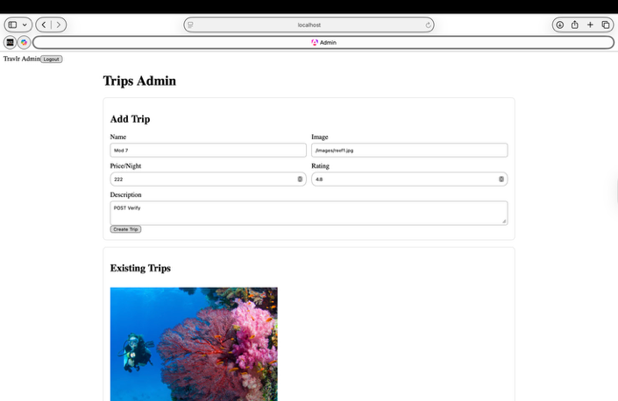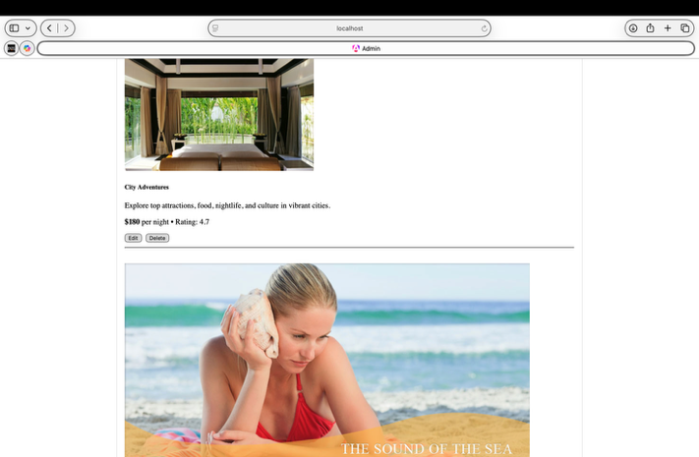

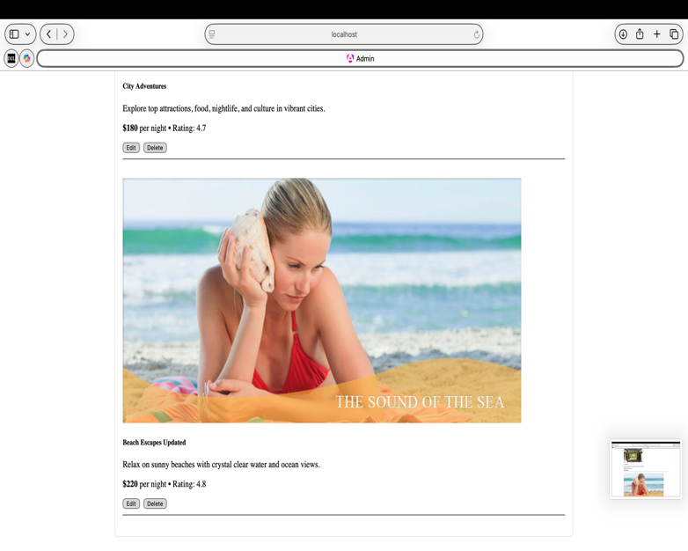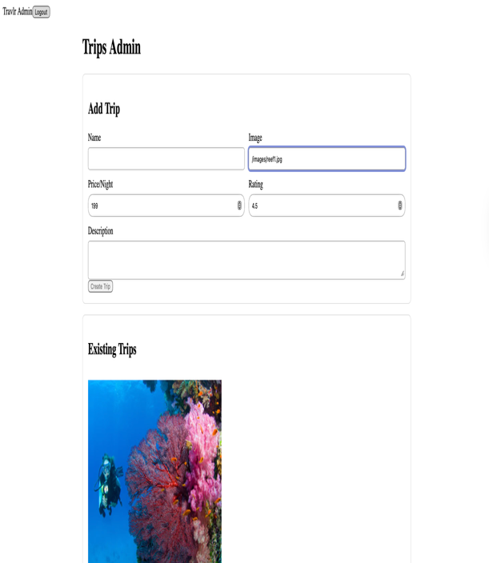

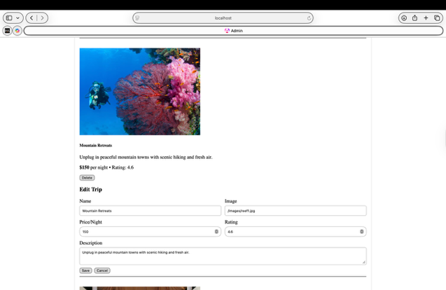

1).The administrative user interface is implemented as a Single-Page Application (SPA) using Angular in the /admin folder. Angular organizes the UI into standalone components, services, and routes. Components control what the user sees and how the page behaves (for example, the login screen and trip management screens). Services handle business logic and API calls using Angular’s HttpClient (for example, the authentication service that requests a token and the trip data service that performs CRUD requests). Routing is handled on the client side with Angular routes so the user can navigate between views without full page reloads.

This differs from the customer-facing Express site, which follows an MVC pattern with routes, controllers, and Handlebars views. In the Express application, each page request goes to the server and the server renders HTML (server-side rendering). In Angular, the application loads once in the browser and then updates the view dynamically using component state and API calls (client-side rendering). As a result, the SPA provides richer functionality such as immediate updates to the trip list after create/update/delete actions, form validation, and a smoother user experience without reloading entire pages.

Security is incorporated into the Angular admin UI through a login form and token-based authentication. After a successful login, the SPA stores the JWT in localStorage and includes it automatically on protected API requests using an HTTP interceptor. This ensures administrative actions (create, update, delete) require authentication before the server processes the request.Describe the process of testing to make sure the SPA is working with the API to GET and PUT data in the database.>
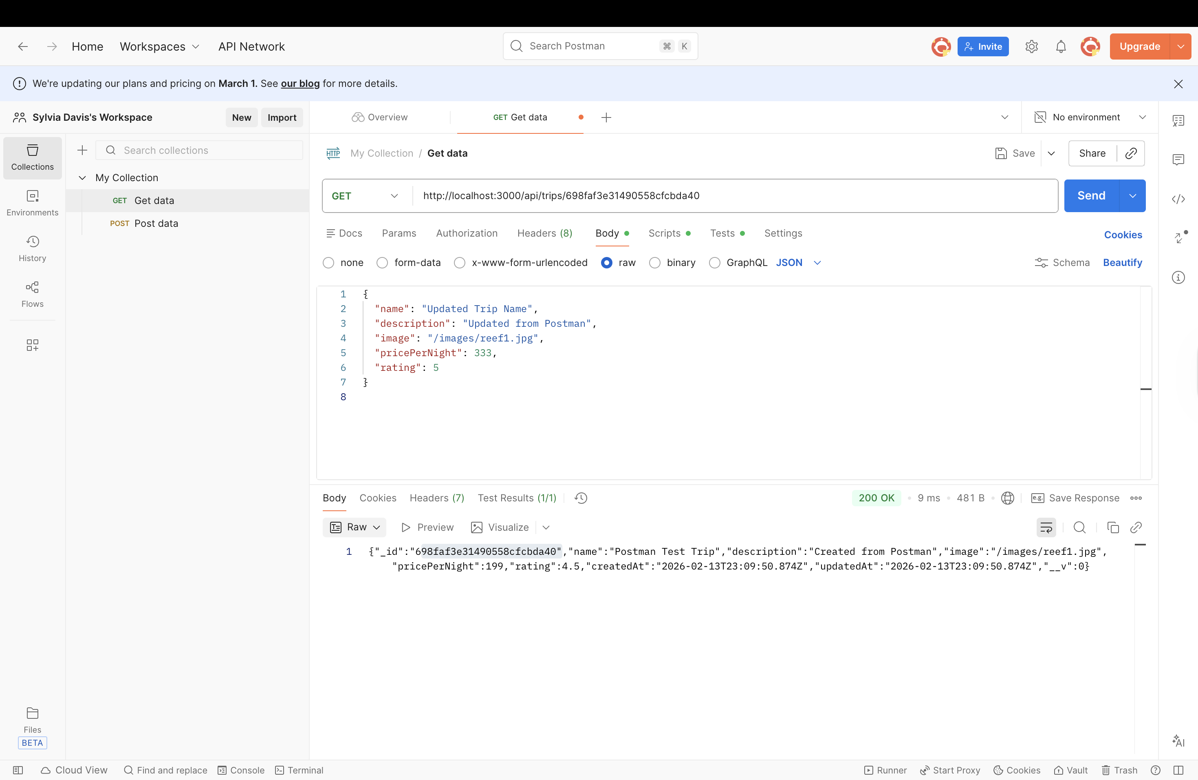

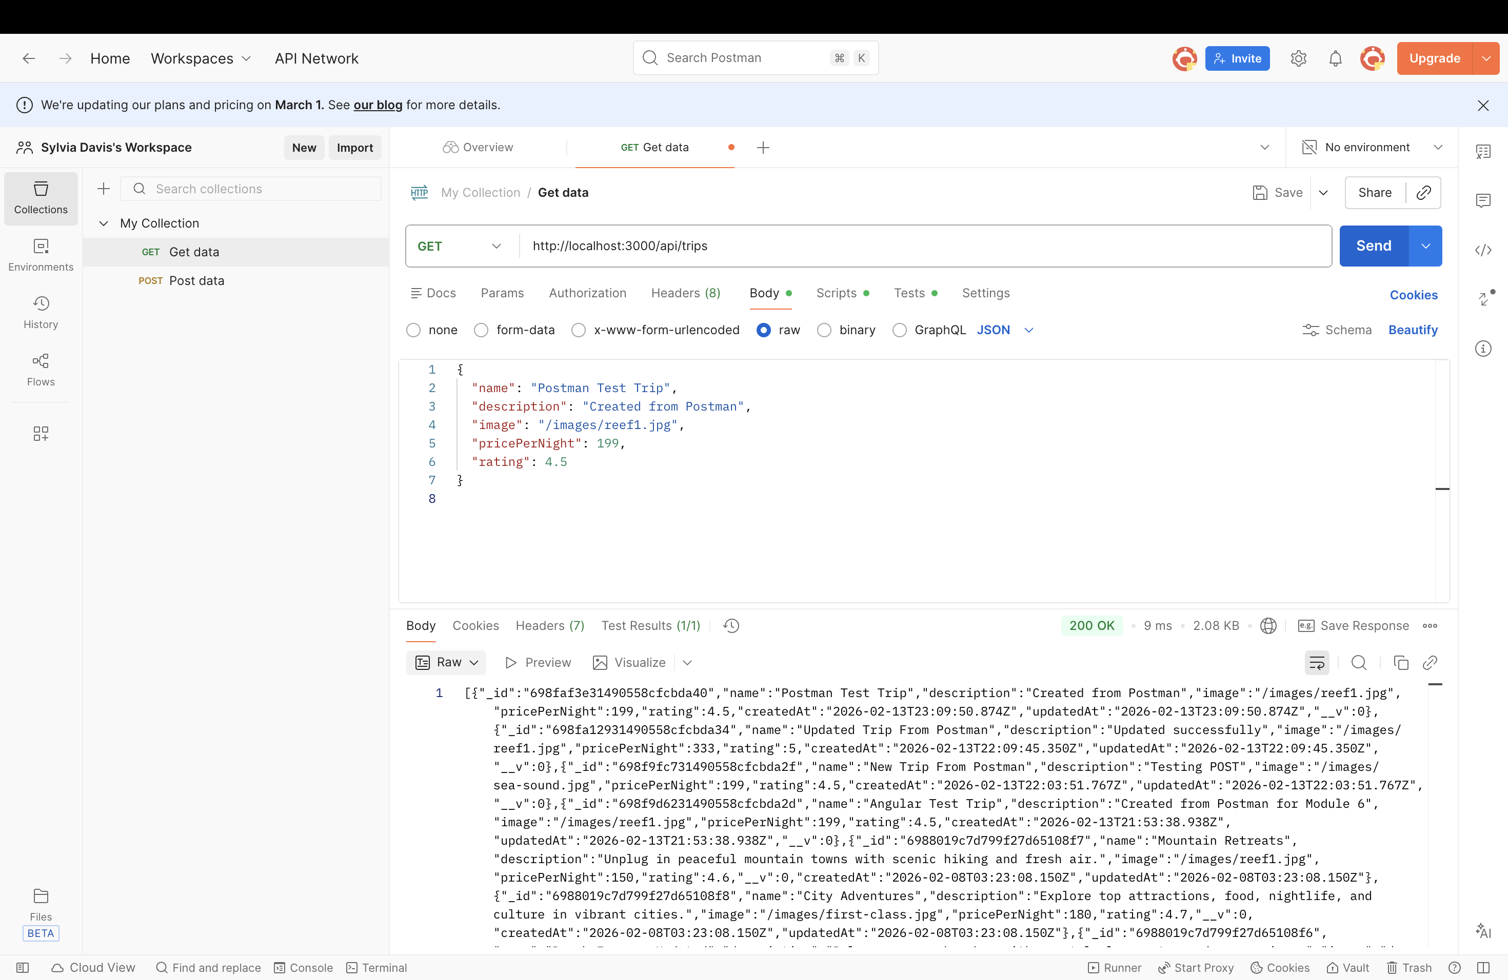

2.) To test that the SPA correctly communicates with the REST API and database, I ran both the Express server and the Angular admin application locally. First, I confirmed the API could return trip data by calling the trip endpoint and verifying that the response returned JSON documents from the MongoDB trips collection (GET). Next, I logged into the admin SPA using mock credentials to obtain a JWT token. After login, I verified that the SPA could retrieve and display the list of trips in the UI (GET), confirming that the UI was rendering live database data rather than static content.

To test updating data (PUT), I selected an existing trip in the admin interface, changed one or more fields (such as name, price per night, rating, or description), and submitted the update. I verified the update in three ways: (1) the SPA refreshed the trip list and displayed the updated values, (2) Postman returned a successful status code (200 OK) for the PUT request with the same changes, and (3) the MongoDB document reflected the updated fields when checked directly in the database. I also verified that protected endpoints rejected unauthenticated requests by attempting an update without a token and confirming the API returned an authorization error. This confirmed that the SPA’s token handling and the server’s protected routes were working correctly.

